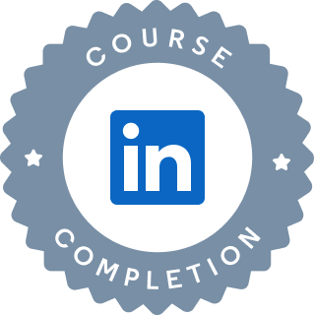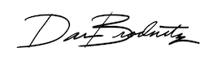

# Hands-On Data Science using SQL, Tableau, Python, and Spark

Hands-On Data Science using SQL, Tableau, Python, and Spark

Course completed by Harshini M D

Nov 22, 2024 at 08:21AM UTC • 1 hour 13 minutes

Top skills covered

Tableau Python (Programming Language) SQL

Head of Global Content, Learning

Certificate ID: 13e41197d26d98ac38159def44dd1dc0d5fdae0d2b6d0dbfce11221a5aa2f55b

## Course completed by Vaishnavi M

Nov 22, 2024 at 08:21AM UTC • 1 hour 13 minutes

## Top skills covered

### Tableau Python (Programming Language) SQL

Head of Global Content, Learning

Certificate ID: 13e41197d26d98ac38159def44dd1dc0d5fdae0d2b6d0dbfce11221a5aa2f55b